# Cars per Capita (1) in Python

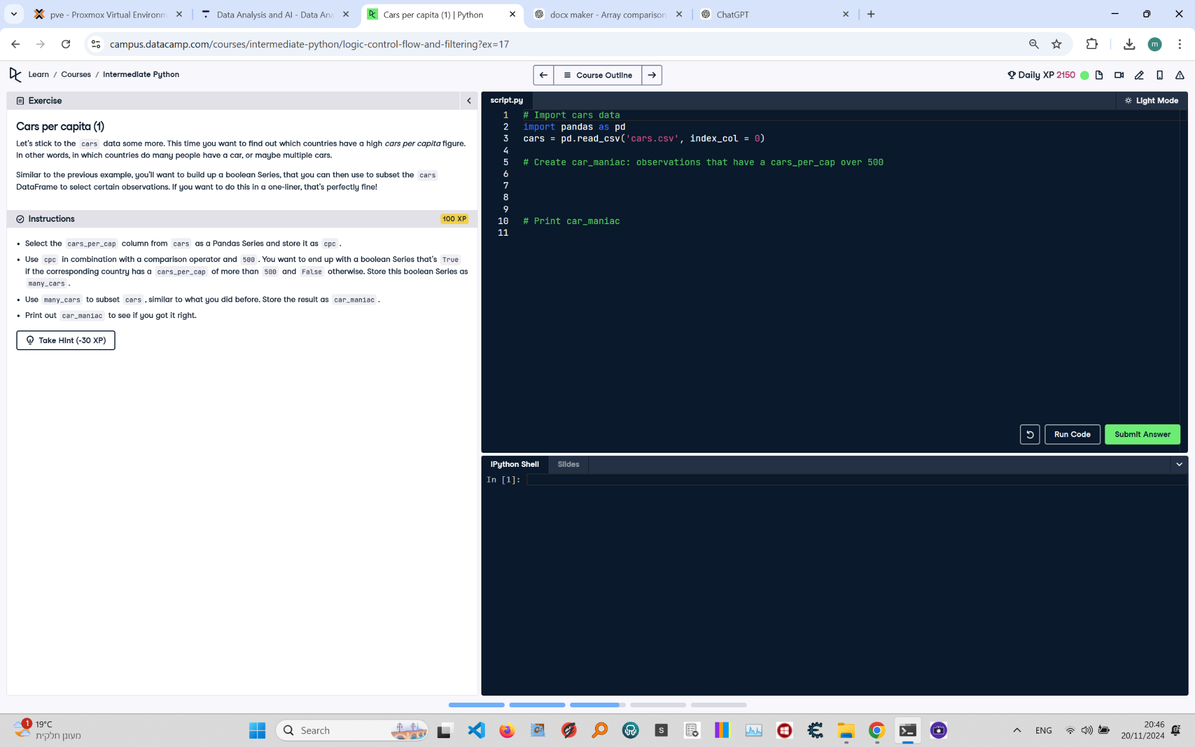

**Question:**

Let's stick to the `cars` data some more. This time you want to find out which countries have a high `cars_per_cap` figure. In other words, in which countries do many people have a car, or maybe multiple cars.  
1. Select the `cars_per_cap` column from `cars` as a Pandas Series and store it as `cpc`.  
2. Use `cpc` in combination with a comparison operator and 500. You want to end up with a boolean Series that's `True` if the corresponding country has a `cars_per_cap` of more than 500 and `False` otherwise. Store this boolean Series as `many_cars`.  
3. Use `many_cars` to subset `cars`, similar to what you did before. Store the result as `car_maniac`.  
4. Print out `car_maniac` to see if you got it right.

**Answer:**

Here is the Python code that solves the problem:

# Import cars data  
import pandas as pd  
  
# Read the dataset  
cars = pd.read_csv('cars.csv', index_col=0)  
  
# Select cars_per_cap column as Series: cpc  
cpc = cars['cars_per_cap']  
  
# Create many_cars: boolean Series for cars_per_cap > 500  
many_cars = cpc > 500  
  
# Use many_cars to subset cars: car_maniac  
car_maniac = cars[many_cars]  
  
# Print car_maniac  
print(car_maniac)

**Explanation:**

1. **Import Pandas**: The Pandas library is imported to handle tabular data in a DataFrame.  
2. **Read the dataset**: The `pd.read_csv()` function reads the dataset from a CSV file into a Pandas DataFrame. The `index_col=0` parameter sets the first column as the index.  
3. **Extract `cars_per_cap` column**: The `cars_per_cap` column is extracted as a Pandas Series and stored in `cpc`.  
4. **Create boolean Series**: The `cpc > 500` comparison creates a boolean Series indicating which countries have a `cars_per_cap` greater than 500. This boolean Series is stored in `many_cars`.  
5. **Subset DataFrame**: The `cars[many_cars]` expression uses the boolean Series to filter the rows where `cars_per_cap` is greater than 500. The result is stored in `car_maniac`.  
6. **Print the result**: The `print(car_maniac)` statement displays the subsetted DataFrame.